Enhanced Health Monitoring System Using Google Pixel Sensors

Shreya Tadipaneni, Sai Tejaswi Chakravaram; CSC 6228 - Security in IOT

Additional Concepts

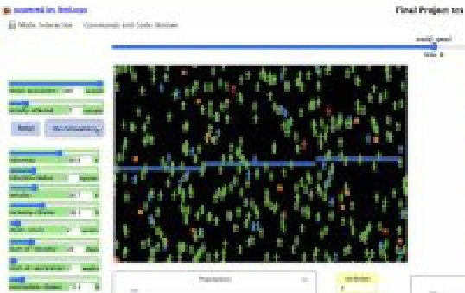

......

- - ----

## RESULTS

In the modern digital age, smartphones have become indispensable tools for managing health and wellness. The advanced sensor technologies embedded in devices like Google Pixel provide a unique opportunity to revolutionize health monitoring.

This project focuses on leveraging Google Pixel sensors to create a comprehensive **Enhanced Health Monitoring System**. By integrating multiple sensors, such as the accelerometer, gyroscope, ambient light sensor, and barometer, our system delivers real-time insights into physical activity, environmental conditions, and overall well-being.

Unlike existing health apps that often leave data fragmented and insights limited, our solution combines these data streams into a unified, actionable platform. The result is a powerful tool for tracking physical activity, analyzing sleep patterns, and monitoring altitude-related fitness metrics, empowering users with valuable insights for better health management.

!Disease-Modeling Techniques; Highliight the different dise·ase modleliing t,echni:que"s1 such as agent-ba:sed models1 compa1rtmentail models (like SIR or SEIR model:s)1 and other-compulartiun.ll! apprro.aehes used in eprdlel!l!l!ioiogy to s.tudy diiseas.e spr•e-ad.

VacdnatiomStrategies=Expiore wriou.s vaccination strategies1 iinducliing herrtl immunity, ta1"ge1ted vacciinatiom eampaigns1 and th.e !impact of diff-erenl (""Over.age irates or vacciine ,effi.cac:ies on dilSea.se control.

Environmental Fadon; Discuss the inliue-:nce -of environmental fa.clou on choler-a transmission such a.s wate·r quality, s:aniiltaitron infrastructwl"ei diim:ate pattem.s, and theii1riimcor-pm·atio.n inll:o simulation moclii:!ls.

!Publiic H,ealtb tnterveotiicms: Address the role of puibliic health ii.Dlten•emi:ons

beyond vacciination1 like hygiene p1romotiun1 '\vater-trea:tment, co,mmurmiity engagem.enlt and their electivene:.\tSin dmioleifa [Prevention.

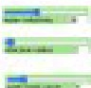

--..J!"'W .._

------'--

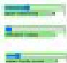

## I . I-

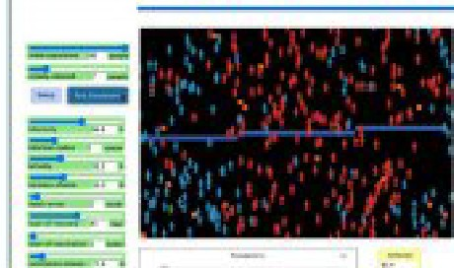

-- - --

--

--

* Key Features of vibrio cholerae
  1. Microbial Chairaetre.risties:
     + **Viibrio** Cholera i&a Gram- negative, c111rved rod-shap,eed bact,eriun1.

, 1t is motile due to siing]e I pofar·flagetlu m1 aUm Jng it to move actively iio aqueom environments

* 1. Toxin :Fioduclion:

+ 7.he Prirn,ary virulence factor iis the dwler.a 11:m::in,¥ hk.h ii-s: respons.ible

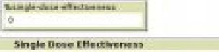 

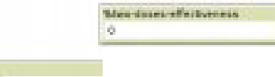

"""-·

The methodology employs an a ent-based modd throu h etLo o·to i, simulate a complex sy.s.tem focusin on individ111alls l\fith varying heaJlth

IZl

,*i*.

i

I

sftat-uses. Key metrics Uke age, movement p:aJtterru.1 contaminated water

e.,:posure, and contact with cholera bacteria are researched and im.plemented 0

L.,.,--.

- - --

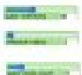



.-· --

l '

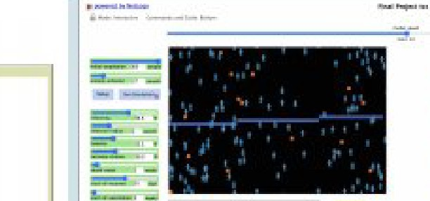

for the characteristiics p.rofuse wat,e1ry dfarrhe.a seen iim.cho(.e_ra pati.ents.

, Cholera toxin is encoded by genes :1oca1ted on the haete.ri.a.1chtomosorne

to monitor population health dynamics. By adjusting thes.e .metries1 multiple

:ff t<

and can l.ead to dehydration and e ectrolyte imbalances

3, Mode ofTransmi.ssion:

, Viibrio Cholerae cam.sm:iread .in Aquatic ,environm,eoitrsinclu.ding .rivers, estuaries .and coastaJll w:aters.

* 'The lhact:e.riu.m often forrms biofi!l.ms on surf.aeres, conlr.ribuling ili:o its

per\!iislr.ence in the env.ironment.

cholera

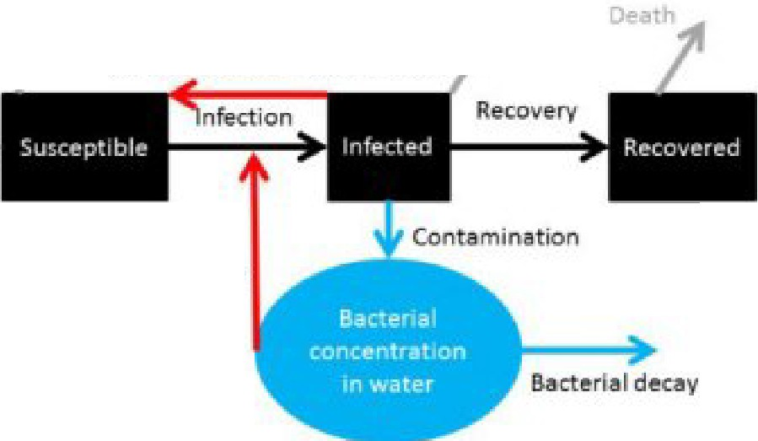

* ***f***

**umon-lo-hum•n•tron>mi>Sion**

simnuEalion.runs visuallize outcomes parhieuEarEy the impact OH. th.remnall healthy population, aiding choEe.ra eradication strategies ·under different conditions.

Research explores.lhe Unk !between initial vaccination rates and population sur ..i,iral1 revealing that hea,,iEy vacc1n.ated populations tend to have higher avera e surviival rates. Further simulation runs and additional features like varied .states of water resources en.l!Jance the model, potentially aiding pubHc health.efforts in optimirzlng vaccination drives.

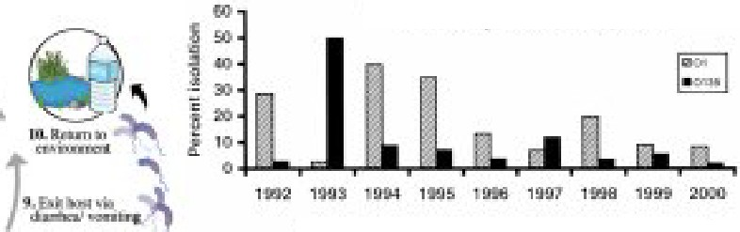

ll5ola11on ol II' Gl'IG(r.,1ur o, and CllJ.'9•111 th t.D. 111) In ei,lr.ull , India

**Dilelltl** or *II,*

01'"" IJ1J8 t th" i(;□(:!R,CI

REFERENCES

1 **htips,:/**'""""""·.cdlc.gov/m.ol,«a/gcru::raVi11dH.html thi.rt,ren

1. https://1w,-w.,odc.gov/clioE ra/gcncml/indcx.html#onc
2. \VHO •Chckra. (il,anc,r:as:ed on iii Dl!'.-01'.'.mbu 20''12)];:ZD.22 Availabk ,nnli.nc: https:// nw.whojnt}ncw!51rmam/mt-sborts/dcta.il/molr'ra

,I \YHO\\"ldy..EpidcmioL Rei:-_2.016; alum.c '91.:43.'.2-,1,410. [Googl.e Scliolar.]

5 V.i:a.lford N_S_Dl!:lllDgr.aphic arml ;5,(!Jdal conilc:.t of dairths.dm·ing t!l:u: Ul54,c-ho]o.r3 aut:bn::ak in &loo, Lendon: A reappraisal afDirJohn.Snow's invc.stipi:io1LHc:dtb Plac:,e. 20:MJ;fi.5:102402. doi: 10.l016/fhc.aJtbplacc.2D:m.m2402. [l'MC free uliclc] [IPulJModl] [C ros;sRc:f] [Google &holair]

6,.bttpsJ/v,-w,-v.•.n.etlogm1,=:b.org/lB/lllnch#bttpsJ/www.nctloga"" c=:b.org/us.ct.s/modck'lib/Sampli!1l20Ji.fodels/Sodal%:!OSdcnce/Segr, a.tiolli nlog.o

B rt j

-'!il

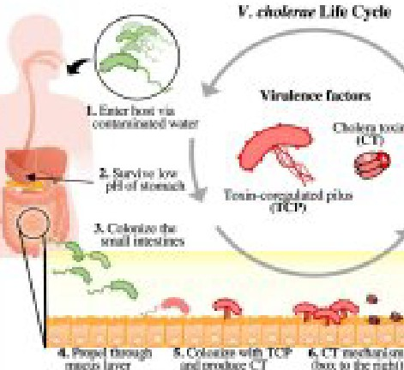Exposure

Hi:isjlllill In **DNklr, B.ln La.l,:;sh**

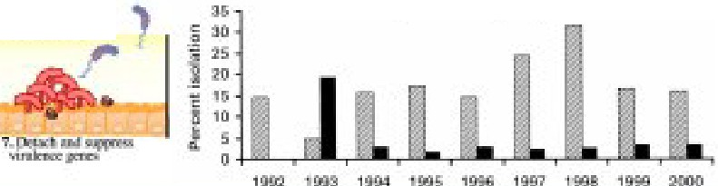

**!l,IMJ,;,e, l'<f**

lq'D.ClillffJl'I.I

# FUTURE STEPS

Our 1re.sea1rch can help lti:o infor-m public heaWth of mor-e effed:ive cholera prevel!l!tioo and co:ru:rnl sitlfategie.s and epidemiology of cholera will. help in understanding ho'\\•the dis ease spreads, identifying at-r'.is**k** popuilaittion:s, and

i.mplemel!l!tiing col!litrol.measures in iti:he frubllll"e outhFeaiks.

# ACKNOWLEDG EMEN:TS

I nprc.ss mysi111L'Cr,c gmtitudc:lo my prof sllr, Arm.lo Mikler, **and** TA"Si for thcir invaluable:guidaoa:::e, surppod1 and c:ncaur.agemc:nt lhn:n.1,ghout the research **an.cl** dcvc1apmcml 11rraccss. I mend *my* .appreciati1J11b1::J thr: lll}' l!eam member for ihdir ,coHaboratimm and.,d.t:dil:".alio:n, which lhas playnl a c::ru:da] mlc:i111th,c dcvdopmcnt and a: uticm oFthi5 prnjc:d.

**CJ** Scanned with OKENScanner